GitHub Link - <https://github.com/ravitripathi2015/RaviTripathi_ReactJS_Lab4/tree/main/expense-tracker-app>

* Create project’s structure
  + server
  + client

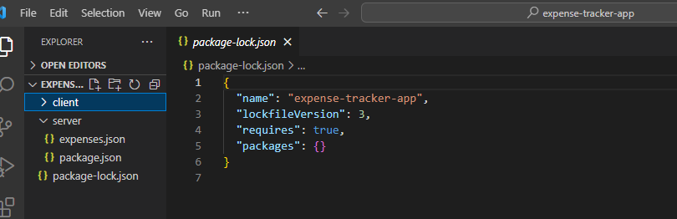

* Server Component - SampleExpenses JSON

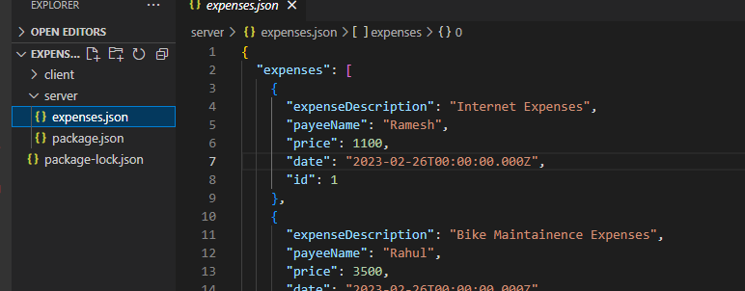

* Server Application
  + npm init --yes
  + npm install -g json-server
    - Installation Path
      * C:\Users\{USER_NAME}\AppData\Roaming\npm
  + Add support for “npm start”
  + URL
    - [http://localhost:4000/](http://localhost:4000/expenses)
* Client Application
  + Cd client
  + Run the command
    - npx create-react-app expanse-tracker-app. --template typescript
* Client Application - Cleanup
  + Remove the files
    - App.css
    - App.test.tsx
    - Index.css
    - logo.svg
  + Changed files
    - Index.tsx
      * Remove the reference to ‘index.css’
    - App.tsx
      * Logo.svg
      * App.css

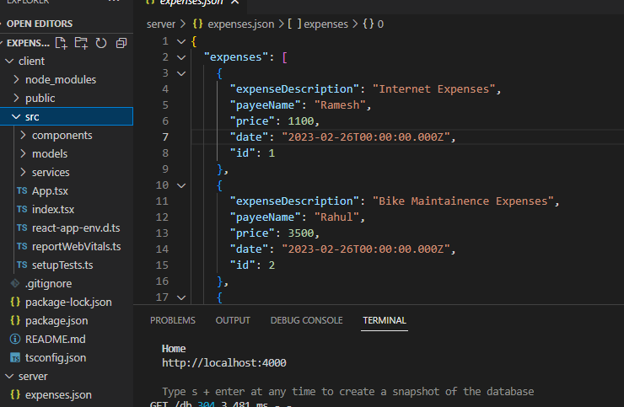

function App() {

return (

<div className="App">

Expense Tracker App

</div>

);

}

* Create ExpenseTrackerApp component
  + Include this in the <App> component

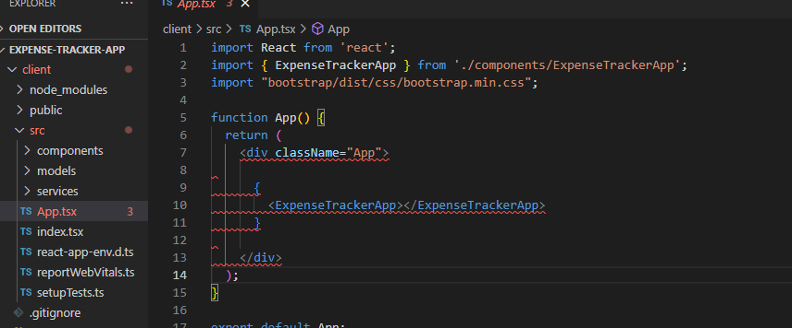

* Define the model for ‘expense-item’
  + /src/models/expense.ts

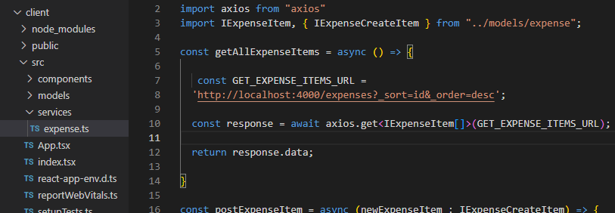

* API method to retrieve ‘all-expense-items’
  + npm install axios
  + /src/services/expense.ts
* Verification of ‘getAllExpenseItems’
  + ExpenseTrackerApp.tsx
* Rendering the ‘expense-items’
  + Command
    - npm install react-bootstrap bootstrap
  + Files Affected
    - ExpenseItems.tsx
    - ExpenseTrackerApp.tsx
    - App.tsx
* Passing the ‘expense-items’ from ‘ExpenseTrackerApp’ to ‘ExpenseItems’ component
  + Files Affected
    - ExpenseItems.tsx
    - ExpenseTrackerApp.tsx
* ExpenseByPayee
  + To display the list of payees along with the contributed expense
  + Files Affected
    - ExpenseByPayee.tsx
    - ExpenseTrackerApp.tsx
* ExpenseCreator - Part I
  + Files Affected
    - ExpenseCreator.tsx
    - ExpenseTrackerApp.tsx
* ExpenseCreator - Part I
  + Files Affected
  + Items
    - // Form -> to be embedded within the Modal.Body
    - // Form - to have 4 fields
    - // Payee - Select / List Box
    - // Add Form.Select for the payee
    - // Modal Title Change, Button title change
* ExpenseCreator - Part III
  + Files Affected
    - ExpenseCreator.tsx
    - Expense.ts
    - ExpenseByPayee.tsx
  + Items
    - Refactor this getAllPayeeNames
      * Moving this to expense.ts
    - Update the ExpenseByPayee
    - ExpenseCreator
      * Reference payeeNames, make use of map() to generate the <option> tag
* Handling Event
  + Collect the details entered by the user
* Type support for ‘Expense Creation’
* Create New Expense - Implementation
  + Steps
    - // declarate a const of type 'IExpenseCreateItem
    - // call post-expenseItem
    - // print in console
    - // verify expenses.json for the new expense